Marie Kelling
 | Paste in your answers for each step below in this column. Paste your actual SQL text, not a screen shot of it. Paste a screen shot of your Result Grid. Be sure to “Snip” your screen shots as instructed in Assignment 02.
1 | Executive Summary | This database will provide the organization needed for Brenda to keep track of all interactions within her business. It will include tables highlighting the major entities in the business: Customer, Employee, Sale, Shop, Order, Vendor, Product, Ingredient, Recipe, SaleLineItem, IngredientRecipe, OrderLineItem. Each of these tables will contain records of the respective information for that entity. Each entity will have a visualized relationship with at least one other table, keeping track of the interactions within the system. Using this database will increase efficiency as well as improvement and growth of the company, allowing Brenda to pinpoint problems or areas in need of attention.
2 | EER Diagram | 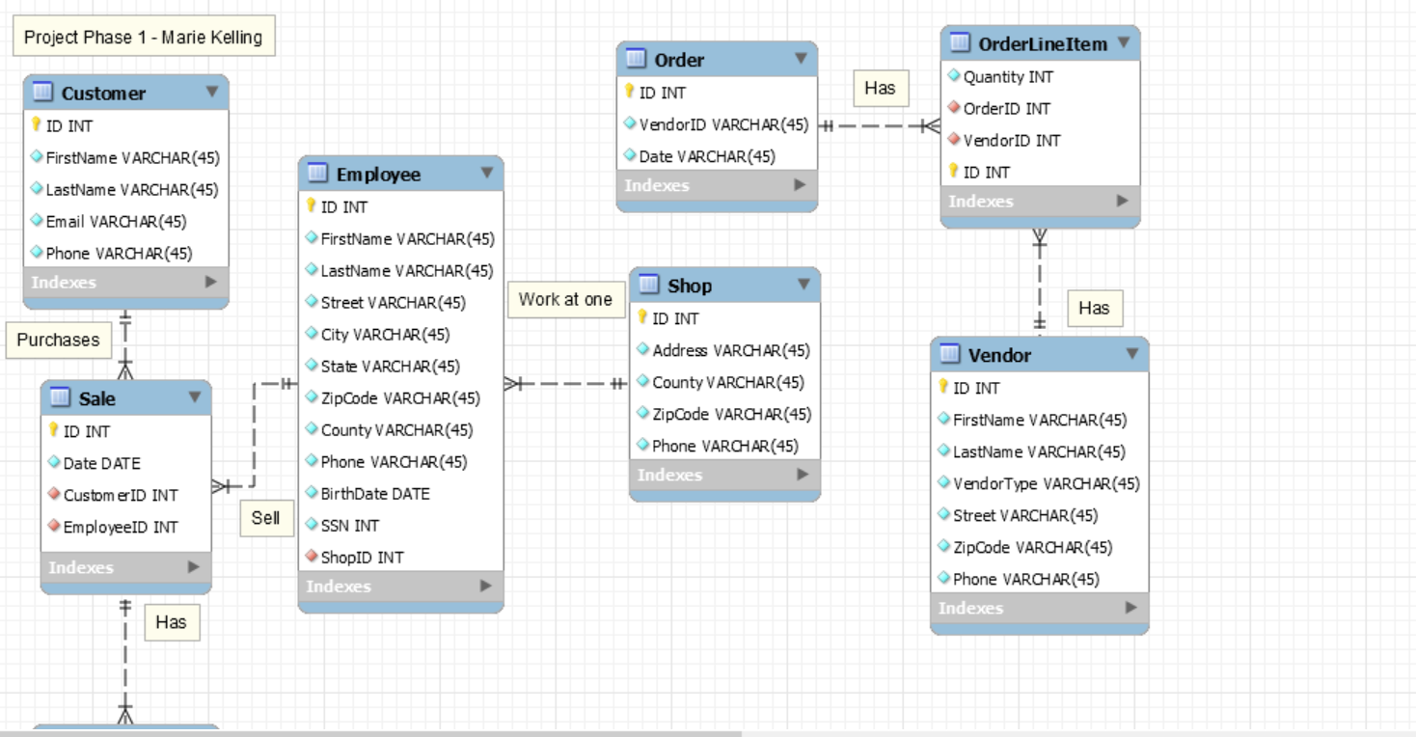  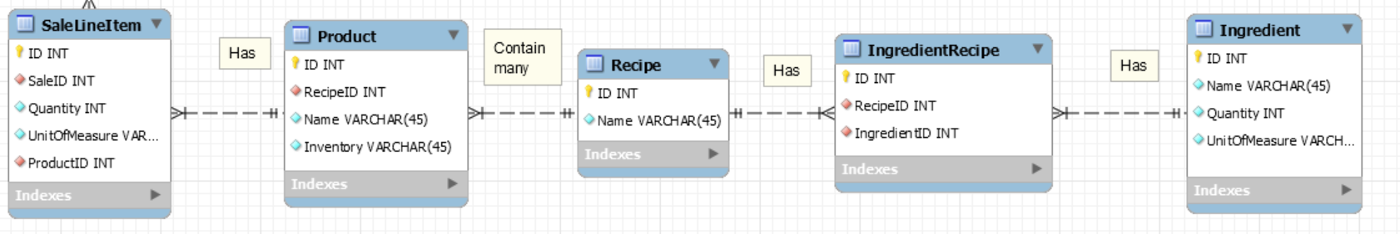
3 | Crayon Definition
  Entity Name | Crayon Definition
  Customer | The Customer table contains records of each customer’s personal information
  Employee | The Employee table keeps track of each employee’s personal information and the shop they’re associated with
  Sale | The Sale table keeps track of the employee who made the sale and the shop the sale was made at
  Shop | The Shop table contains records of each shops location information
  Order | The Order table keeps track of the vendor and the date the order was placed
  Vendor | The Vendor table contains records of each vendor’s location and personal information
  Recipe | The Recipe table keeps track of the recipes used to make the shop’s products
  Product | The Product table contains records of the products sold to customers
  Ingredient | The Ingredient table contains records for the ingredients needed for the shop’s recipes
  Ingredient-Recipe | Implements the many-to-many relationship between Ingredients and Recipes
  Sale-Line-Item | Implements the many-to-many relationship between Sales and Products
  Order-Line-Item | Implements the many-to-many relationship between Orders and Vendors
3 | Biz Rules | - Each employee can only work at one shop location  - Customers can place multiple orders, but each order can only be associated with one customer  - Each sale can only be associated with one employee and one customer, however employees can make multiple sales  - Orders can be associated with many vendors, and each vendor can have multiple orders  - Each sale can include any number of products, and products can be associated with more than one sale
4 | Output Requirements

